Criterion C: Analysis

Task 1: Recognizing slope of a graph

1. What do you mean by the word steeper?

2. Observe the two graph lines shown below. The lines represent the motion of two cars.

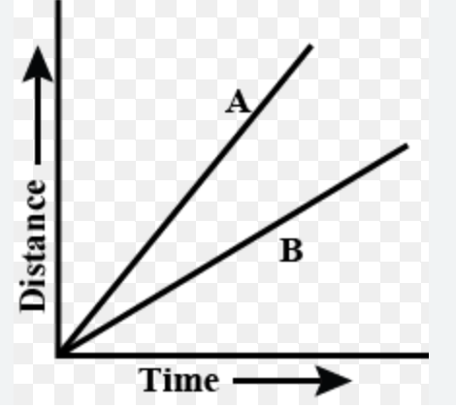

3. Which is the steeper line in the image?

4. Try to think of two ways you can prove that its steeper?

Task 2: Meaning of slope

Observe the images given below and answer the questions

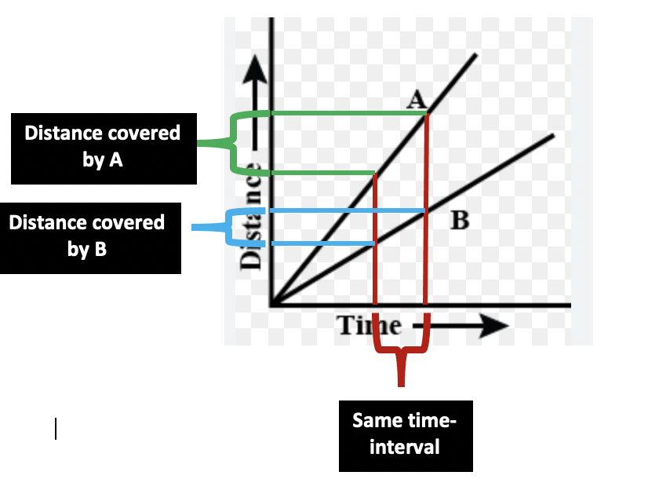

1. Within the same time interval, find which car travelled greater distance?

2. How does the slope of that graph compare with the other car? Is it steeper or less steeper?

Observe the image given below and answer question
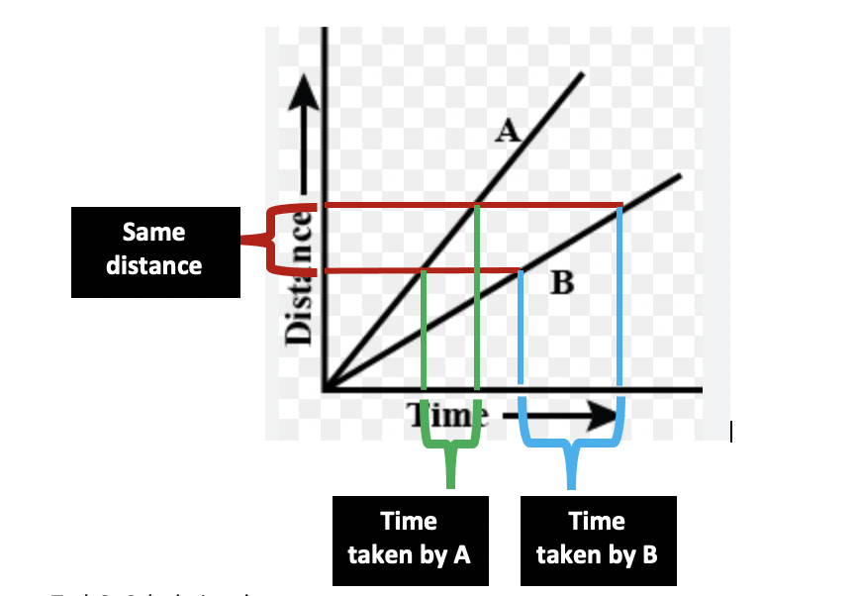

3. For the same distance, find which car took a longer time?

4. State your conclusion about the relationship between the speed and the steepness of the line.

5. Complete the following sentences based on the words provided:
lesser
greater
smaller
equal
larger
different
same

For the ________ change in time, car A covers a ___________ distance.

For the _______ change in time, car B covers a ___________ distance.

For the ________ change in distance, car A takes a ___________ time.

For the ________ change in distance, car B covers a ___________ distance.

Task 3: Calculating slope

Observe the image given below and answer the questions below:

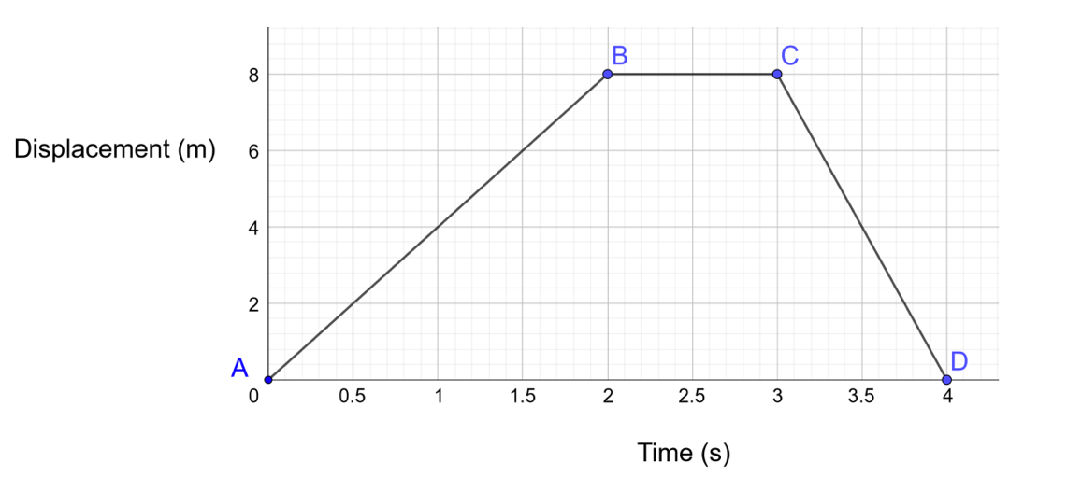

1. Calculate the velocity of the object at 1 second.

This is called as the instantaneous velocity at the given time.

2. What is the total change in time from point A to B?

Change in time =

3. What is the displacement from point A to B?

Displacement =

4. Calculate the velocity of the object from point A to B? (Q 2 and 3 are your clues)

Velocity =

5. Observe the representation of this change in time and displacement on the graph:
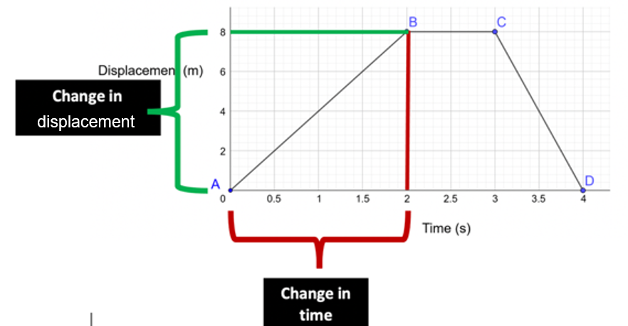
We call this as Rise and Run as shown below.
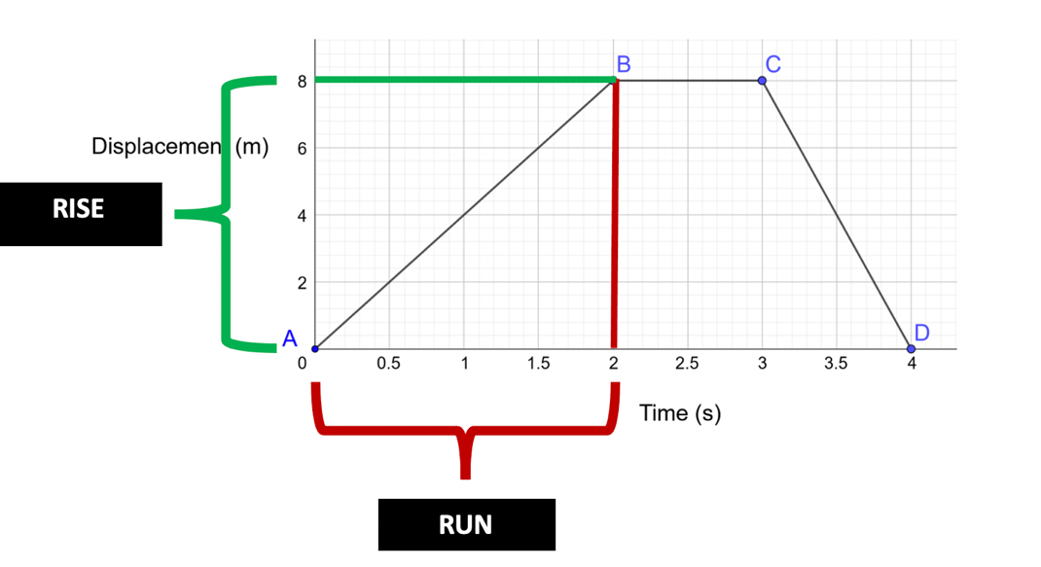

6.
a. What are the units of rise?

b. What are the units of run?

7. Hence if you divide rise and run of a graph, what quantity do you get? Write in the form of formula to help you think:

8. Hence by calculating the rise/run of a displacement-time graph, we are actually calculating the _________ of the object.

9. Using the same formula for velocity, rewrite it using rise and run

10. By calculating the rise/run of a distance-time ggraph, we are actually calculating the _________ of the object.

Formula:

This is also called as the slope or gradient of the graph.

